Requirements:
- Solar Panel
- Arduino Uno
- Mechanical base
- Photo Resistor
- Servo Motor
- Battery
- Power supply Modell MB 102

Solar cell: solar cell is that use to produce electrical energy from the light energy in general. Nowadays, the solar system has used to produce the electrical energy in most of the countries through the world. The first practical solar cells were made less than 30 years ago. Obviously, there some types of the solar cell those have their own specific properties. By passing the time the solar cell developments has deployed.
1. Amorphous Silicon Solar Cell (A-Si): Amorphous silicon (a-Si) is the non-crystalline form of silicon. It is the most well-developed of the thin film technologies having been on the market for more than 15 years.
2. Bio hybrid Solar Cell: A bio hybrid solar cell is a solar cell made using a
combination of organic matter (photosystem I) and inorganic matter. Bio hybrid solar cells have been made by a team of researchers at Vanderbilt University. The team used the photosystem I (a photoactive protein complex located in the thylakoid membrane) to recreate the natural process of photosynthesis to obtain a greater efficiency in solar energy conversion. These bio hybrid solar cells are a new type of renewable energy. [3][4]
3. Buried Contact Solar Cell: The buried contact solar cell is a high efficiency
commercial solar cell technology based on a plated metal contact inside a laser-formed groove. The buried contact technology overcomes many of the disadvantages associated with screen-printed contacts and this allows buried contact
solar cell to have performance up to 25% better than commercial screen-printed solar cells.
4. Cadmium Telluride Solar Cell (CdTe): Cadmium telluride (CdTe) photovoltaics describes a photovoltaic (PV) technology that is based on the use of cadmium telluride, a thin semiconductor layer designed to absorb and convert sunlight into electricity.[10] Cadmium telluride PV is the only thin film technology with lower costs than conventional solar cells made of crystalline silicon in multi-kilowatt systems.[6][7][8]
5. Toxicity of Cadmium: Cadmium is one of the top 6 deadliest and toxic materials
known. However, CdTe appears to be less toxic than elemental cadmium, at least in terms of acute exposure.This is not to say it is harmless. Cadmium telluride is toxic if ingested, if its dust is inhaled, or if it is handled improperly (i.e. without appropriate gloves and other safety precautions). The toxicity is not solely due to the cadmium content. One study found that the highly reactive surface of cadmium
telluride quantum dots trigger extensive reactive oxygen damage to the cell membrane, mitochondria, and cell nucleus. In addition, the cadmium telluride films are typically recrystallized in a toxic compound of cadmium chloride. The disposal and long-term safety of cadmium telluride is a known issue in the large-scale commercialization of cadmium telluride solar panels. Serious efforts have been made to understand and overcome these issues. Researchers from the U.S. Department of Energy's Brookhaven National Laboratory have found that large-scale use of CdTe PV modules does not present any risks to health and the environment and recycling the modules at the end of their useful life resolves any environmental concerns. During their operation, these modules do not produce any pollutants, and furthermore, by displacing fossil fuels, they offer great environmental benefits.
6. Concentrated PV Cell (CVP and HCVP): Following the sun. A Concentrating Photovoltaic (CPV) system converts light energy into electrical energy in the
same way that conventional photovoltaic technology does but uses an advanced optical system to focuses a large area of sunlight onto each cell for maximum efficiency. Different CPV designs exist, sometimes differentiated by the concentration factor, such as low-concentration (LCPV) and high concentration (HCPV). Concentrator photovoltaics’ (CPV) is a photovoltaic technology that generates electricity from sunlight. Contrary to conventional photovoltaic systems,
it uses lenses and curved mirrors to focus sunlight onto small, but highly efficient, multi-junction (MJ) solar cells. In addition, CPV systems often use solar trackers and sometimes a cooling system to further increase their efficiency. [20]:30 Ongoing research and development is rapidly improving their competitiveness in the utility-scale segment and in areas of high solar insulation.
7. Copper Indium Gallium Selenide Solar Cells (CI (G) S): One of the most interesting and controversial materials in solar is Copper-Indium-Gallium-Selenide, or CIGS for short. It was part of a solar thin-film-hype cycle where some CIGS companies such as Solyndra, Nano Solar and MiaSolé almost became household names. A copper indium gallium selenide solar cell (or CIGS cell, sometimes CI(G)S or CIS cell) is a thin film solar cell used to convert sunlight into electric power. They are manufactured by depositing a thin layer of copper, indium, gallium and selenide on glass or plastic backing, along with electrodes on the front and back to collect current. Because the material has a high absorption coefficient and strongly absorbs sunlight, a much thinner film is required than of other semiconductor materials.
8. Dye-Sensitized Solar Cell (DSSC): Dye Sensitized solar cells (DSSC), also sometimes referred to as dye sensitized cells (DSC), are a third generation photovoltaic (solar) cell that converts any visible light into electrical energy. This new class of advanced solar cell can be likened to artificial photosynthesis due to the way in which it mimics nature’s absorption of light energy. Dye Sensitized solar cells (DSSC) were invented in 1991 by Professor Michael Graetzel and Dr Brian O’Regan at École Polytechnique Fédérale de Lausanne (EPFL), Switzerland
and is often referred to as the Gräetzel cell, we call it G Cell.

Arduino Uno:
The Arduino Uno is a microcontroller board based on the ATmega328 (datasheet). It has 14 digital input/output pins (of which 6 can be used as PWM outputs), 6 analog inputs, a 16 MHz crystal oscillator, a USB connection, a power jack, an ICSP header, and a reset button. It contains everything needed to support the microcontroller; simply connect it to a computer with a USB cable or power it with a AC-to-DC adapter or battery to get started.
The Uno differs from all preceding boards in that it does not use the FTDI USB-to-serial driver chip. Instead, it features the Atmega8U2 programmed as a USB-to-serial converter.
"Uno" means one in Italian and is named to mark the upcoming release of Arduino 1.0. The Uno and version 1.0 will be the reference versions of Arduino, moving forward. The Uno is the latest in a series of USB Arduino boards, and the reference model for the Arduino platform; for a comparison with previous versions.
See the index of Arduino boards.
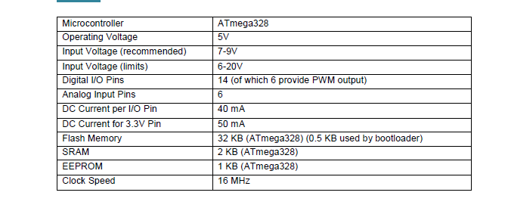

Photo Resistor:
The photoresistor, which consists of the semiconductor material cadmium-sulphide, has a spectral responsivity similar to that of the human eye with maximum responsivity in the green spectral range of light. Photoresistors of
this type are particularly suitable for the detection of visible light.
The electrical resistance changes considerably according to the illumination intensity. In the dark, the photoresistor has a high resistance and in the light a low resistance. The illumination intensity (Lux unit, in short lx) can be
determined by measuring the resistance via the characteristic curve of the sensor.

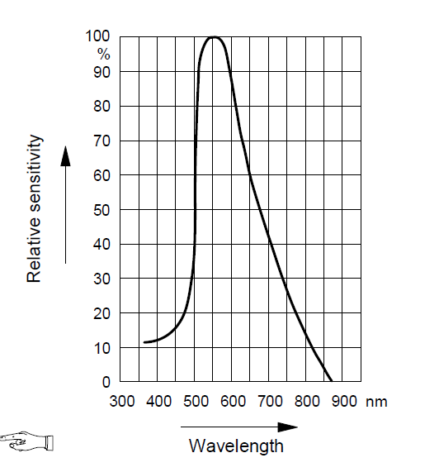

Servo motor:
servo motors you can position the motor shaft at a specific position (angle) using control signal. The motor shaft will hold at this position as long as the control signal not changed. This is very useful for controlling robot arms, unmanned airplanes control surface or any object that you want it to move at certain angle and stay at its new position. Servo motors may be classified according to size or torque that it can withstand into mini, standard and giant servos. Usually mini and standard size servo motors can be powered by Arduino directly with no need to external power supply or driver

Power supply Modell MB 102:
Breadboard power supply module, compatible with 5V, 3.3V apply to MB102 Breadboard, its input voltage is 6.5_12V (DC) or USB power supply and the output voltage is 3.3V and 5V can switch. Also, maximum output current is smaller than 0.7A .
Fluctuation two road independent control can switch over to 0 V, 3.3 V, 5 V
On-board two groups of 3.3V, 5V DC output plug pin, convenient external lead use.
Size:5.3cm x 3.5cm

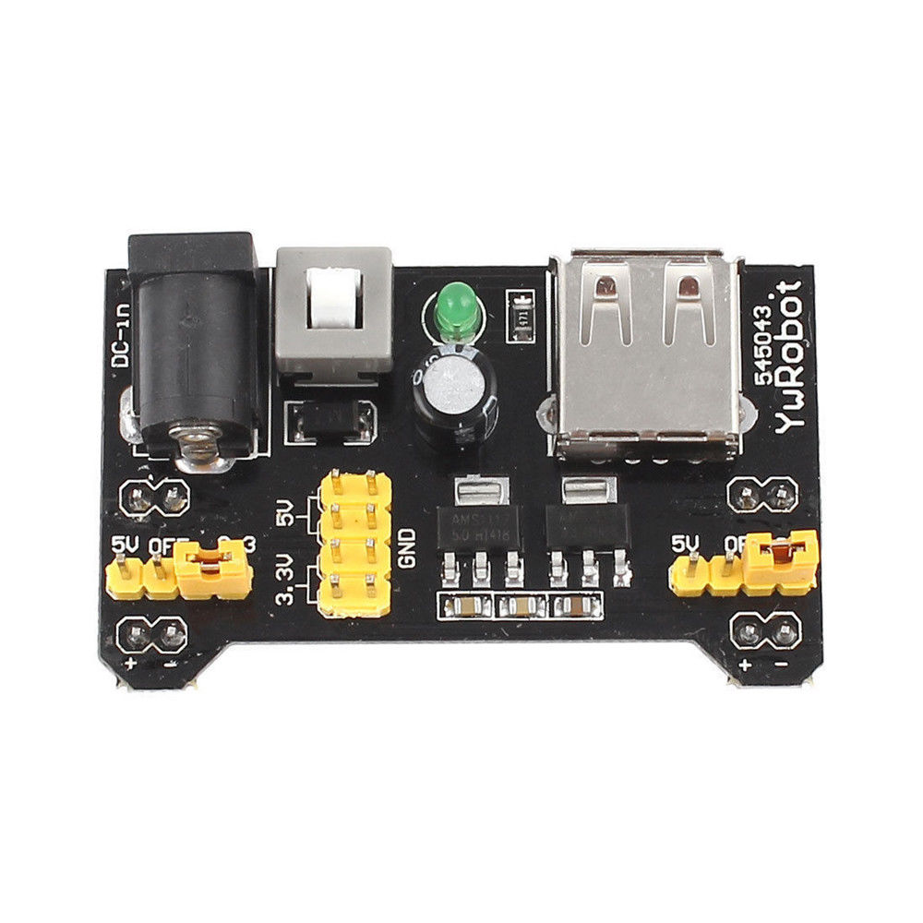

General description about the project:
As we know, the solar cell itself cannot track the light of the sun. Obviously, more time of lighting to the solar cell means more output or increase the efficiency. Here I will try to manage a system that makes the solar panel be able to track and be faced to the sun.
To make a tracking system we need some tools such as: two motors (Servo Motor), mechanical setup of the standing which made by Aluminum, An Arduino Uno board, Photo Resistor,
After making the standing, it is needing to setup the servo motor in two different position of the standing to get it the ability of the rotating in two direction. The rotation of the servos depends on the Arduino board function that means it will be control by Arduino. Also, the functionality of the Arduino depends on the Photo Resistor sensor.
The shape of the putting and the number of the photo resistors are important. They will put in the same plane of the panel face to the sun. But, they should be separate of each other by the dam. The dam is like the wall between all four photo resistors that means the somewhere near the solar panel they will lay in 2cm*2cm place, but that place has departed by two wall and make it four quarter and in each quarter one photo resistors will set. This case if the position of the sun will change one or two of the quarters will be dark and the Arduino will get signal about this event, so it will send data to servo motor and they will rotate in the direction of that quarter. So, by this way every time the solar panel will be face to the sun.

